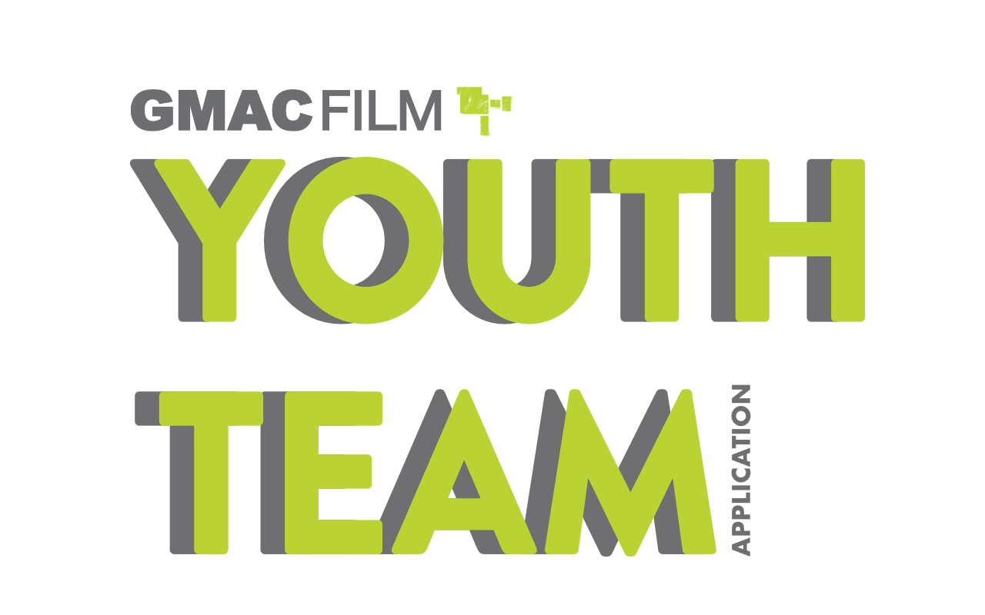

We are looking for committed young people to join our youth team!
The GMAC Film Youth Team are the youth board of GMAC Film. We meet at least once a month and give thoughts and opinions on the upcoming years youth filmmaking program. We also run events, which can vary from practical filmmaking, to industry speakers to a quiz night!
We also have the chance to create our own projects as a youth team, and opportunities for professional development in the industry.

You are eligible to apply to be a member of the youth team if:
- You have taken part in a GMAC Film activity (Summer School, BFI Film Academy, attended Youth Team events etc.)
- You are 16 – 25 years old
- You are Glasgow based.
- Able to commit to at least one meeting a month. Dates will be confirmed, but will be an evening between 6 – 8pm.
- Be able to keep regular contact with each other and staff at GMAC Film (emails, group chat)

This is a written application, however if you would prefer to complete it in a different form (video, sound recording etc.) then please feel free to record your answers and put a link in the boxes provided. Any questions on this don’t hesitate to ask – email us at youthteam@gmacfilm.com.

Name:
Date of Birth:
Address:
Postcode:
Contact Number:
Email Address:

Have you taken part in a GMAC Film activity before? | Yes | No
If YES, tell us which and what you enjoyed?

Why would you like to be a member of our youth team? What would you like to learn?

What will you bring to our youth team? Give an example of an event you’d like to run.

Please return this form by midday MONDAY 10^{h} FEBRUARY 2020

By Post: Youth Team, GMAC Film, 5th floor, Trongate 103, Glasgow, G1 5HD
By Email: youthteam@gmacfilm.com

We will be in contact shortly after to let you know if you have a place.
GOOD LUCK!

Equality, Diversity and Inclusion Questionnaire

GMAC Film cares about representing everybody in the film industry. We take this information in order to allow us to run inclusive and diverse projects. It also helps us to gather information for our funders. Please fill in as thoroughly as possible.

Your information will be stored securely in compliance with the Data Protection Act (1998) and the General Data Protection Regulation (GDPR) (EU) 2016/679.

Thanks!

Gender
Please indicate the gender you most identify with

Male
Female
Transgender
Prefer to self-describe
Other
Prefer not to say

Disability
Bottom of Form
Please indicate if you consider yourself disabled

Yes
No
Prefer not to say

If you answered Yes - do you have any of the following conditions which have lasted, or are expected to last, at least 12 months?
Visual impairment

Hearing impairment/deaf

Physical disabilities

Cognitive or learning disabilities

Mental health condition

Other long term/chronic condition

Other (please specify)

Prefer not to say

Additional Support
Do you require any additional support or resources?

If yes, please give details:

Sexual Orientation
Please indicate how you identify your sexual orientation:

Heterosexual/Straight
Gay/Lesbian
Bisexual
Other
Prefer to self-describe
Prefer not to say

Ethnicity
Please indicate your ethnic group:

White Scottish / White British
Irish
Gypsy / Traveller
Polish
White Other, please specify:
Asian/Asian Scottish/Asian British
Chinese/Chinese Scottish/Chinese British
African/African Scottish/African British
Caribbean/Caribbean Scottish/Caribbean British
Black/Black Scottish/Black British
Arab/Arab Scottish/Arab British
Mixed or Multiple Ethnic Groups, please specify:
Other, please specify:
Prefer not to say

Gaelic Speaking

Bottom of Form
Do you regard yourself as a Gaelic speaker?

Gaelic speaker(s)
Gaelic learner(s)
No
Prefer not to say

Religion and Beliefs
Please indicate your religion or belief:

None
Buddhist
Christian
Hindu
Jewish
Muslim
Sikh
Other (please specify)
Prefer not to say

Care Experience
Are you a young carer?

Yes
No
Prefer not to say

Are you or have you been in accommodated care?

Yes
No
Prefer not to say

